**Star Alliance Los Angeles Lounge named  
North America's Leading Airport Lounge at the  
World Travel Awards 2024**

Star Alliance’s Los Angeles airport lounge has been honoured with the title of North America's Leading Airport Lounge for the fifth year running at this year's prestigious World Travel Awards. The award was announced at the Caribbean & The Americas Gala Ceremony held on the scenic island of Saint Vincent on July 1, 2024.

Star Alliance CEO Theo Panagiotoulias commented on the victory, saying: "Our aim at Star Alliance is to make air travel more effortless and stress-free. Lounges are essential for improving the airport experience, and our Star Alliance LAX lounge has been a standout since its inception. We are excited that it has been recognised as one of the top in the industry consistently."

Mr Panagiotoulias acknowledged the team and continued: "I want to express my heartfelt appreciation to the hardworking team that ensures our LAX lounge operates flawlessly around the clock. Additionally, I thank our Star Alliance member airlines for their ongoing partnership, which has contributed to the lounge's success over the years."

The Star Alliance lounge at Los Angeles International Airport is renowned as one of the finest airport lounges globally, consistently earning prestigious industry accolades. Featuring an outdoor terrace with firepits, a water wall, and panoramic views of the Hollywood Hills, the sprawling 18,000-square-foot lounge captures the essence of Californian charm through the day and transforms into a lively space as night descends. For those seeking a calm pre-flight experience or a space to work and dine, the lounge provides ample opportunities to unwind and enjoy.

The World Travel Awards celebrate and recognise excellence across key sectors of the travel, tourism and hospitality industries. Established in 1993, it is one of the most prestigious award programmes in travel and tourism.

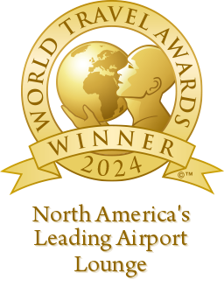

**About Star Alliance**

The Star Alliance network was established in 1997 as the first truly global airline alliance, based on a customer value proposition of global reach, worldwide recognition, and seamless service. Since inception, it has offered the largest and most comprehensive airline network, with a focus on improving customer experience across the Alliance journey.

The member airlines are: Aegean Airlines, Air Canada, Air China, Air India, Air New Zealand, ANA, Asiana Airlines, Austrian, Avianca, Brussels Airlines, Copa Airlines, Croatia Airlines, EGYPTAIR, Ethiopian Airlines, EVA Air, LOT Polish Airlines, Lufthansa, Scandinavian Airlines, Shenzhen Airlines, Singapore Airlines, South African Airways, SWISS, TAP Air Portugal, THAI, Turkish Airlines, and United.

Overall, the Star Alliance network currently offers more than 17,000 daily flights to over 1,200 airports in 190 countries. Further connecting flights are offered by Star Alliance Connecting Partner Juneyao Airlines.

Star Alliance Press Office:

+65 8729 6691; [mediarelations@staralliance.com](http://?)

Visit our [website](http://?](http://?) [](http://?) [](http://?) [](http://?)

